Experiment No. 1
Problem Statement:
Simulate a three nodes point-to-point network with duplex links between them. Set the queue size vary the bandwidth and find the number of packets dropped.
#File Name: ns_exp1.tcl
#Description: Simulating simple three nodes point-to-point network
##################################################################

set ns [new Simulator]

#Open a new file for NAMTRACE
set nf [open out.nam w]
$ns namtrace-all $nf

#Open a new file to log TRACE
set tf [open out.tr w]
$ns trace-all $tf

#Body of the finish procedure
proc finish {} {
global ns nf tf
$ns flush-trace
close $nf
close $tf
exec nam out.nam &
exit 0
}

#Create Nodes
set n0 [$ns node]
set n1 [$ns node]
set n2 [$ns node]

#Create Links between Nodes
$ns duplex-link $n0 $n1 1Mb 10ms DropTail
$ns duplex-link $n1 $n2 1Mb 10ms DropTail

#Set the queue limit - default is 50 packets
$ns queue-limit $n0 $n1 50
$ns queue-limit $n1 $n2 50

#Create Transport Agent
set udp0 [new Agent/UDP]
$ns attach-agent $n0 $udp0
set null0 [new Agent/Null]
$ns attach-agent $n2 $null0
$ns connect $udp0 $null0

#Create Application to generate traffic
set cbr0 [new Application/Traffic/CBR]
$cbr0 set packetSize_ 500
$cbr0 set interval_ 0.005
$cbr0 attach-agent $udp0

#Start and Stop generating traffic

Nam output:
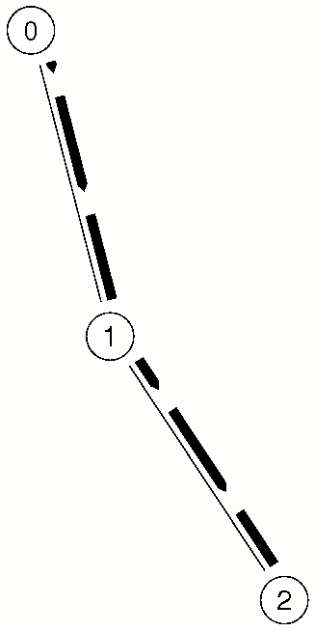

Experiment No. 2
Problem Statement:
Simulate a four node point-to-point network, and connect the links as follows: n0-n2, n1-n2 and n2-n3. Apply TCP agent between n0-n3 and UDP n1-n3. Apply relevant applications over TCP and UDP agents changing the parameter and determine the number of packets by TCP/UDP.

#File Name: ns_exp2.tcl
#Description: Simulating four node point-to-point network with TCP and UDP agent #################################################################################

set ns [new Simulator]

#Open a new file for NAMTRACE
set nf [open out.nam w]
$ns namtrace-all $nf

#Open a new file to log TRACE
set tf [open out.tr w]
$ns trace-all $tf

#Body of the 'finish' procedure
proc finish {} {
global ns nf tf
$ns flush-trace
close $nf
close $tf
exec nam out.nam &
exit 0
}

#Create Nodes
set n0 [$ns node]
set n1 [$ns node]
set n2 [$ns node]
set n3 [$ns node]

#Create Links between Nodes
$ns duplex-link $n0 $n2 1Mb 10ms DropTail
$ns duplex-link $n1 $n2 1Mb 10ms DropTail
$ns duplex-link $n2 $n3 1Mb 10ms DropTail

#Set the queue limit - default is 50 packets
$ns queue-limit $n0 $n2 50
$ns queue-limit $n1 $n2 50
$ns queue-limit $n2 $n3 50

#Create TCP Agent between node 0 and node 3
set tcp0 [new Agent/TCP]
$ns attach-agent $n0 $tcp0
set sink0 [new Agent/TCPSink]
$ns attach-agent $n3 $sink0
$ns connect $tcp0 $sink0

#Create FTP Application for TCP Agent
set ftp0 [new Application/FTP]
$ftp0 attach-agent $tcp0

#Specify TCP packet size
Agent/TCP set packetSize_ 1000

#Create UDP Agent between node 1 and node 3
set udp0 [new Agent/UDP]
$ns attach-agent $n1 $udp0
set null0 [new Agent/Null]
$ns attach-agent $n3 $null0
$ns connect $udp0 $null0

#Create CBR Application for UDP Agent
set cbr0 [new Application/Traffic/CBR]
$cbr0 set packetSize_ 500
$cbr0 set interval_ 0.005
$cbr0 attach-agent $udp0

#Start and Stop FTP Traffic
$ns at 0.75 "$ftp0 start"
$ns at 4.75 "$ftp0 stop"

#Start and Stop CBR traffic
$ns at 0.5 "$cbr0 start"
$ns at 4.5 "$cbr0 stop"

#Stop the simulation
$ns at 5.0 "finish"

#Run the simulation
$ns run

NAM output:
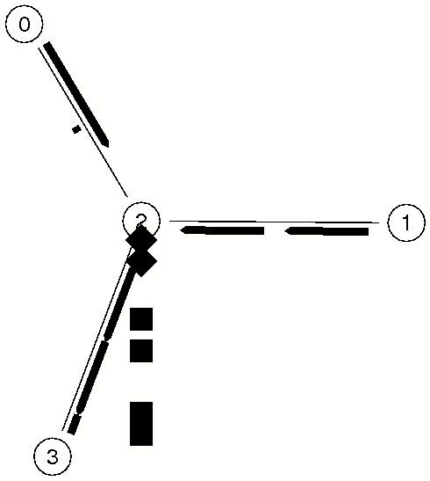

Experiment No. 3
Problem Statement:
Simulate the different types of Internet traffic such as FTP a TELNET over a network and analyze the throughput.
#File Name: ns_exp3.tcl
#Description: Simulating different types of Internet traffic ############################################################

set ns [new Simulator]

#Open a new file for NAMTRACE
set nf [open out.nam w]
$ns namtrace-all $nf

#Open a new file to log TRACE
set tf [open out.tr w]
$ns trace-all $tf

#Body of the 'finish' procedure
proc finish {} {
global ns nf tf
$ns flush-trace
close $nf
close $tf
exec nam out.nam &
exit 0
}

#Create Nodes
set n0 [$ns node]
set n1 [$ns node]
set n2 [$ns node]
set n3 [$ns node]

#Create Links between Nodes
$ns duplex-link $n0 $n2 1Mb 10ms DropTail
$ns duplex-link $n1 $n2 1Mb 10ms DropTail
$ns duplex-link $n2 $n3 1Mb 10ms DropTail

#Set the queue limit - default is 50 packets
$ns queue-limit $n0 $n2 50
$ns queue-limit $n1 $n2 50
$ns queue-limit $n2 $n3 50

#Create TCP Agent between node 0 and node 3
set tcp0 [new Agent/TCP]
$ns attach-agent $n0 $tcp0
set sink0 [new Agent/TCPSink]
$ns attach-agent $n3 $sink0
$ns connect $tcp0 $sink0

#Create FTP Application for TCP Agent
set ftp0 [new Application/FTP]
$ftp0 attach-agent $tcp0

#Specify TCP packet size
Agent/TCP set packetSize_ 1000

#Create TCP Agent between node 1 and node 3
set tcp1 [new Agent/TCP]
$ns attach-agent $n1 $tcp1
set sink1 [new Agent/TCPSink]
$ns attach-agent $n3 $sink1
$ns connect $tcp1 $sink1

#Create Telnet Application for TCP Agent
set telnet0 [new Application/Telnet]
$telnet0 set interval_ 0.005
$telnet0 attach-agent $tcp1

#Start and Stop FTP Traffic
$ns at 0.75 "$ftp0 start"
$ns at 4.75 "$ftp0 stop"

#Start and Stop Telnet traffic
$ns at 0.5 "$telnet0 start"
$ns at 4.5 "$telnet0 stop"

#Stop the simulation
$ns at 5.0 "finish"

#Run the simulation
$ns run

NAM output
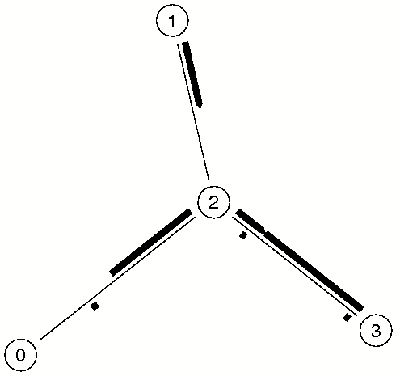

Experiment No. 4
Problem Statement:
Simulate the transmission of ping messaged over a network topology consisting of 3-6 nodes and find the number of packets dropped due to congestion.
#File Name: ns_exp4.tcl
#Description: transmission of ping messaged over a network topology ###################################################################

#Create a simulator object
set ns [new Simulator]

#Open a trace file
set nf [open out.nam w]
$ns namtrace-all $nf

#Define a 'finish' procedure
proc finish {} {
global ns nf
$ns flush-trace
close $nf
exec nam out.nam &
exit 0
}

#Create three nodes
set n0 [$ns node]
set n1 [$ns node]
set n2 [$ns node]

#Connect the nodes with two links
$ns duplex-link $n0 $n1 1Mb 10ms DropTail
$ns duplex-link $n1 $n2 1Mb 10ms DropTail

#Define a 'recv' function for the class 'Agent/Ping'
Agent/Ping instproc recv {from rtt} {
$self instvar node_
puts "node [$node_ id] received ping answer from \
$from with round-trip-time $rtt ms."
}

#Create two ping agents and attach them to the nodes n0 and n2
set p0 [new Agent/Ping]
$ns attach-agent $n0 $p0

set p1 [new Agent/Ping]
$ns attach-agent $n2 $p1

#Connect the two agents
$ns connect $p0 $p1

#Schedule events
$ns at 0.2 "$p0 send"
$ns at 0.4 "$p1 send"
$ns at 0.6 "$p0 send"
$ns at 0.6 "$p1 send"
$ns at 1.0 "finish"

#Run the simulation
$ns run

NAM output:

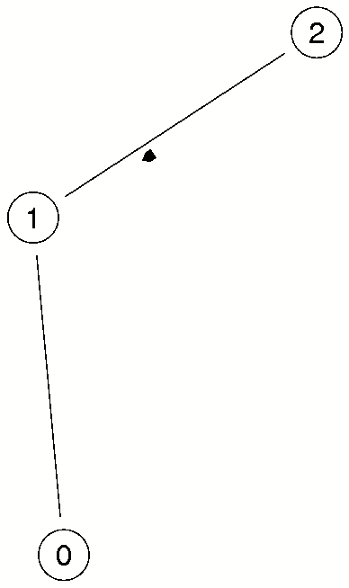
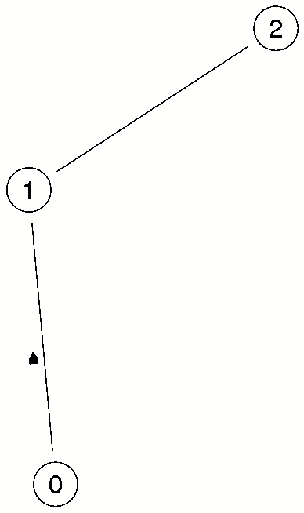

Node 2 sends Node 0 replies

Experiment No. 5
Problem Statement:
Simulate an Ethernet LAN using N-nodes (6-10), change error rate and data rate and compare the throughput.
#File Name: ns_exp5.tcl
#Description: Simulate an Ethernet LAN using N-nodes (6 10)
######################################################################

set ns [new Simulator]

#Open a new file for NAMTRACE
set nf [open out.nam w]
$ns namtrace-all $nf

#Open a new file to log TRACE
set tf [open out.tr w]
$ns trace-all $tf

#Body of the finish procedure
proc finish {} {
global ns nf tf
$ns flush-trace
close $nf
close $tf
exec nam out.nam &
exit 0
}

#Create Nodes
set n0 [$ns node]
set n1 [$ns node]
set n2 [$ns node]
set n3 [$ns node]
set n4 [$ns node]
set n5 [$ns node]
set n6 [$ns node]
set n7 [$ns node]
set n8 [$ns node]
set n9 [$ns node]
set n10 [$ns node]

#Create a Local Area Network (LAN) of 10 Nodes
$ns make-lan "$n0 $n1 $n2 $n3 $n4 $n5 $n6 $n7 $n8 $n9 $n10" 100Mb LL Queue/DropTail Mac/802_3

#Create TCP Agent between node 0 and node 3
set tcp0 [new Agent/TCP]
$ns attach-agent $n0 $tcp0
set sink0 [new Agent/TCPSink]
$ns attach-agent $n3 $sink0
$ns connect $tcp0 $sink0

#Create FTP Application for TCP Agent
set ftp0 [new Application/FTP]
$ftp0 attach-agent $tcp0

#Specify TCP packet size
Agent/TCP set packetSize_ 1000

#Start and Stop FTP Traffic
$ns at 0.75 "$ftp0 start"
$ns at 4.75 "$ftp0 stop"

#Stop the simulation
$ns at 5.0 "finish"

#Run the simulation
$ns run

NAM output:

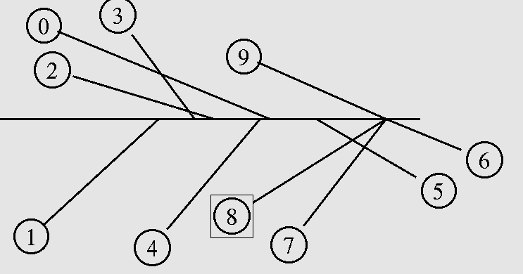

Experiment No. 6
Problem Statement:
Simulate an Ethernet LAN using N nodes and set multiple traffic nodes and determine collision across different nodes.
#File Name: ns_exp6.tcl
#Description: Simulate an Ethernet LAN and set multiple traffic nodes
######################################################################

set ns [new Simulator]

#Open a new file for NAMTRACE
set nf [open out.nam w]
$ns namtrace-all $nf

#Open a new file to log TRACE
set tf [open out.tr w]
$ns trace-all $tf

#Body of the 'finish' procedure
proc finish {} {
global ns nf tf
$ns flush-trace
close $nf
close $tf
exec nam out.nam &
exit 0
}

#Create Nodes
set n0 [$ns node]
set n1 [$ns node]
set n2 [$ns node]
set n3 [$ns node]
set n4 [$ns node]
set n5 [$ns node]
set n6 [$ns node]
set n7 [$ns node]
set n8 [$ns node]
set n9 [$ns node]

#Create a Local Area Network (LAN) of 10 Nodes
$ns make-lan "$n0 $n1 $n2 $n3 $n4 $n5 $n6 $n7 $n8 $n9" 100Mb LL Queue/DropTail Mac/802_3

#Create TCP Agent between node 0 and node 3
set tcp0 [new Agent/TCP]
$ns attach-agent $n0 $tcp0
set sink0 [new Agent/TCPSink]
$ns attach-agent $n3 $sink0
$ns connect $tcp0 $sink0

#Create FTP Application for TCP Agent
set ftp0 [new Application/FTP]
$ftp0 attach-agent $tcp0

#Specify TCP packet size
Agent/TCP set packetSize_ 1000

#Create TCP Agent between node 1 and node 3
set tcp1 [new Agent/TCP]
$ns attach-agent $n1 $tcp1
set sink1 [new Agent/TCPSink]
$ns attach-agent $n3 $sink1
$ns connect $tcp1 $sink1

#Create Telnet Application for TCP Agent
set telnet0 [new Application/Telnet]
$telnet0 set interval_ 0.005
$telnet0 attach-agent $tcp1

#Start and Stop FTP Traffic
$ns at 0.75 "$ftp0 start"
$ns at 4.75 "$ftp0 stop"

#Start and Stop Telnet traffic
$ns at 0.5 "$telnet0 start"
$ns at 4.5 "$telnet0 stop"

#Stop the simulation
$ns at 5.0 "finish"

#Run the simulation
$ns run

Experiment No. 7
Problem Statement:
Simulate an Ethernet LAN using N nodes and set multiple traffic nodes and plot congestion window for different source/destination.
#File Name: ns_exp7.tcl
#Description: Simulate an Ethernet LAN using N nodes and set multiple traffic nodes and plot congestion window for different source/destination.
###############################################################################

set ns [new Simulator]

#Open a new file for NAMTRACE
set nf [open out.nam w]
$ns namtrace-all $nf

#Open a new file to log TRACE
set tf [open out.tr w]
$ns trace-all $tf

#Body of the 'finish' procedure
proc finish {} {
global ns nf tf
$ns flush-trace
close $nf
close $tf
exec nam out.nam &
exit 0
}

#Create Nodes
set n0 [$ns node]
set n1 [$ns node]
set n2 [$ns node]
set n3 [$ns node]
set n4 [$ns node]
set n5 [$ns node]
set n6 [$ns node]
set n7 [$ns node]
set n8 [$ns node]
set n9 [$ns node]

#Create a Local Area Network (LAN) of 10 Nodes
$ns make-lan "$n0 $n1 $n2 $n3 $n4 $n5 $n6 $n7 $n8 $n9" 100Mb LL Queue/DropTail Mac/802_3

#Create TCP Agent between node 0 and node 3
set tcp0 [new Agent/TCP]
$ns attach-agent $n0 $tcp0
set sink0 [new Agent/TCPSink]
$ns attach-agent $n3 $sink0
$ns connect $tcp0 $sink0

#Open a new file to log Congestion Window data
set cfile0 [open tcp0.tr w]
$tcp0 attach $cfile0
$tcp0 trace cwnd_

#Create FTP Application for TCP Agent
set ftp0 [new Application/FTP]
$ftp0 attach-agent $tcp0

#Specify TCP packet size
Agent/TCP set packetSize_ 1000

#Create TCP Agent between node 1 and node 3
set tcp1 [new Agent/TCP]
$ns attach-agent $n1 $tcp1
set sink1 [new Agent/TCPSink]
$ns attach-agent $n3 $sink1
$ns connect $tcp1 $sink1

#Open a new file to log Congestion Window data
set cfile1 [open tcp1.tr w]
$tcp1 attach $cfile1
$tcp1 trace cwnd_

#Create Telnet Application for TCP Agent
set telnet0 [new Application/Telnet]
$telnet0 set interval_ 0.005
$telnet0 attach-agent $tcp1

#Start and Stop FTP Traffic
$ns at 0.75 "$ftp0 start"
$ns at 4.75 "$ftp0 stop"

#Start and Stop Telnet traffic
$ns at 0.5 "$telnet0 start"
$ns at 4.5 "$telnet0 stop"

#Stop the simulation
$ns at 5.0 "finish"

#Run the simulation
$ns run

Experiment No. 8
Problem Statement:
Simulate simple ESS and with transmitting nodes in wire-less LAN by simulation and determine the performance with respect to transmission of packets using NCTUNS

#File Name: ns_exp8.tcl
#Description: simple ESS and with transmitting nodes in wire-less LAN ######################################################################

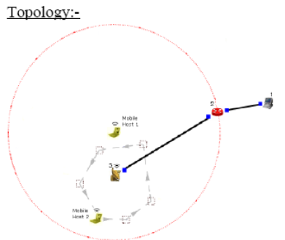

- Click on “access point”. Goto wireless interface and tick on “show transmission range and then click OK.
- Double click on Router -> Node Editor and then
Left stack -> throughput of Incoming packets
Right stack -> throughput of Outgoing packets
- Select mobile hosts and access points then click on.
Tools -> WLAN mobile nodes-> WLAN Generate infrastructure.
Subnet ID: Port number of router (2)
Gateway ID: IP address of router
- Mobile Host 1
ttcp –t –u –s –p 3000 1.0.1.1
- Mobile Host 1
ttcp –t –u –s –p 3001 1.0.1.1
- Host(Receiver)
ttcp –r –u –s –p 3000
ttcp –r –u –s –p 3001
- Run and then play to plot the graph.

